Pranav H

BL.EN.U4AIE21105

* Lab - 2

|  |
| --- |
| import gymnasium as gym import time  import matplotlib.pyplot as plt |

* Environment : CartPole-v1

|  |  |  |  |  |  |  |  |  |  |  |  |  |  |  |  |  |  |  |  |  |
| --- | --- | --- | --- | --- | --- | --- | --- | --- | --- | --- | --- | --- | --- | --- | --- | --- | --- | --- | --- | --- |
| env = gym.make('CartPole-v1', render_mode='human') rewards = [] for _ in range(10):  env.reset() done = False while not done: action = env.action_space.sample() obs,reward,done,x,info = env.step(action) env.render() time.sleep(0.01) rewards.append(reward) env.close() for i,r in enumerate(rewards): print(f"Episode: {i+1} \tReward: {r}") plt.plot(rewards)   |  |  | | --- | --- | | Episode: 1 | Reward: 1.0 | | Episode: 2 | Reward: 1.0 | | Episode: 3 | Reward: 1.0 | | Episode: 4 | Reward: 1.0 | | Episode: 5 | Reward: 1.0 | | Episode: 6 | Reward: 1.0 | | Episode: 7 | Reward: 1.0 | | Episode: 8 | Reward: 1.0 | | Episode: 9 | Reward: 1.0 | | Episode: 10 | Reward: 1.0 |   [<matplotlib.lines.Line2D at 0x2df47ce9dc0>] |

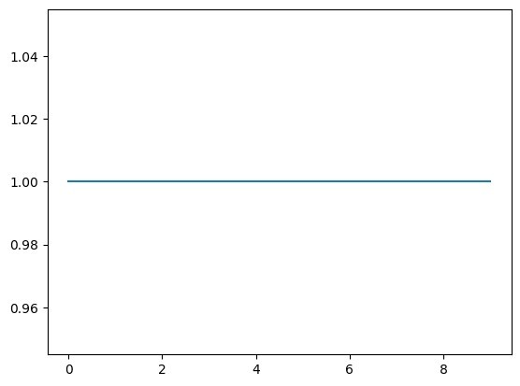

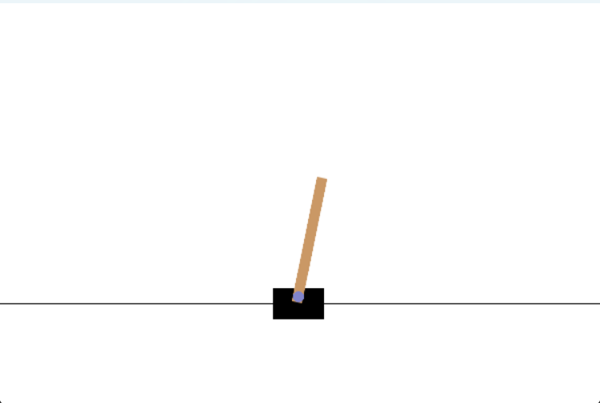

* Environment : LunarLander-v2

|  |  |  |  |  |  |  |
| --- | --- | --- | --- | --- | --- | --- |
| env = gym.make('LunarLander-v2', render_mode='human')  rewards = [] for _ in range(3): env.reset() done = False while not done: action = env.action_space.sample() obs,reward,done,x,info = env.step(action) env.render() time.sleep(0.01) rewards.append(reward) env.close() for i,r in enumerate(rewards): print(f"Episode: {i+1} \tReward: {r}") plt.plot(rewards)   |  |  | | --- | --- | | Episode: 1 | Reward: -100 | | Episode: 2 | Reward: -100 | | Episode: 3 | Reward: -100 |   [<matplotlib.lines.Line2D at 0x2df4affd850>] |

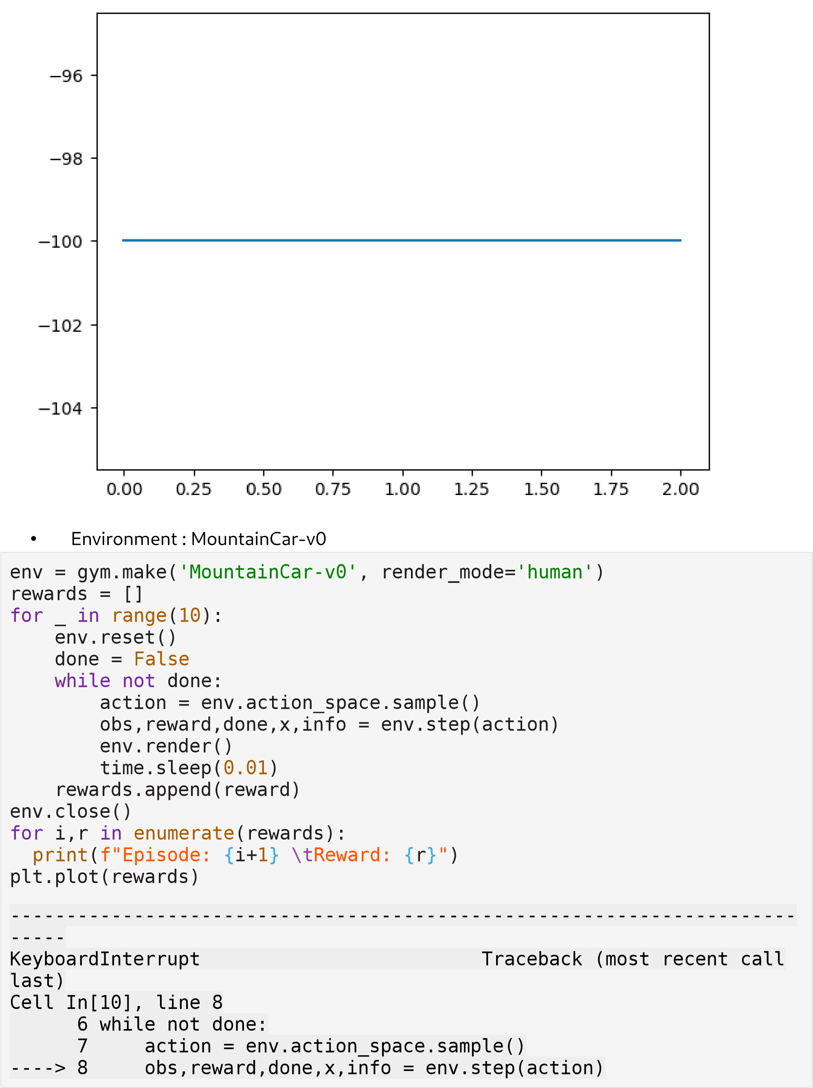

* 1. env.render()
  2. time.sleep(0.01)

File c:\Users\harih\AppData\Local\Programs\Python\Python312\Lib\sitepackages\gymnasium\wrappers\time_limit.py:57, in TimeLimit.step(self, action)

* 1. def step(self, action):
  2. """Steps through the environment and if the number of steps elapsed exceeds ``max_episode_steps`` then truncate.

48

49 Args:

(...) 55

56 """

---> 57 observation, reward, terminated, truncated, info = self.env.step(action)

58 self._elapsed_steps += 1

60 if self._elapsed_steps >= self._max_episode_steps:

File c:\Users\harih\AppData\Local\Programs\Python\Python312\Lib\sitepackages\gymnasium\wrappers\order_enforcing.py:56, in OrderEnforcing.step(self, action)

* 1. if not self._has_reset:
  2. raise ResetNeeded("Cannot call env.step() before calling env.reset()")

---> 56 return self.env.step(action)

File c:\Users\harih\AppData\Local\Programs\Python\Python312\Lib\sitepackages\gymnasium\wrappers\env_checker.py:51, in

PassiveEnvChecker.step(self, action)

* 1. return env_step_passive_checker(self.env, action)
  2. else:

---> 51 return self.env.step(action)

File c:\Users\harih\AppData\Local\Programs\Python\Python312\Lib\sitepackages\gymnasium\envs\classic_control\mountain_car.py:148, in

MountainCarEnv.step(self, action)

* 1. self.state = (position, velocity)
  2. if self.render_mode == "human":

--> 148 self.render()

149 return np.array(self.state, dtype=np.float32), reward, terminated, False, {}

File c:\Users\harih\AppData\Local\Programs\Python\Python312\Lib\sitepackages\gymnasium\envs\classic_control\mountain_car.py:266, in

MountainCarEnv.render(self)

* 1. if self.render_mode == "human":
  2. pygame.event.pump()

--> 266 self.clock.tick(self.metadata["render_fps"])

267 pygame.display.flip()

|  |
| --- |
| 269 elif self.render_mode == "rgb_array":  KeyboardInterrupt: |

